Name: P. Sai Hallticket:2303A52395 Aissginment:5.4 Task1:
Prompt: Prompt GitHub Copilot to generate a Python script that collects user data (e.g., name, age, email). Then, ask Copilot to add
comments on how to anonymize or protect this data. Code:
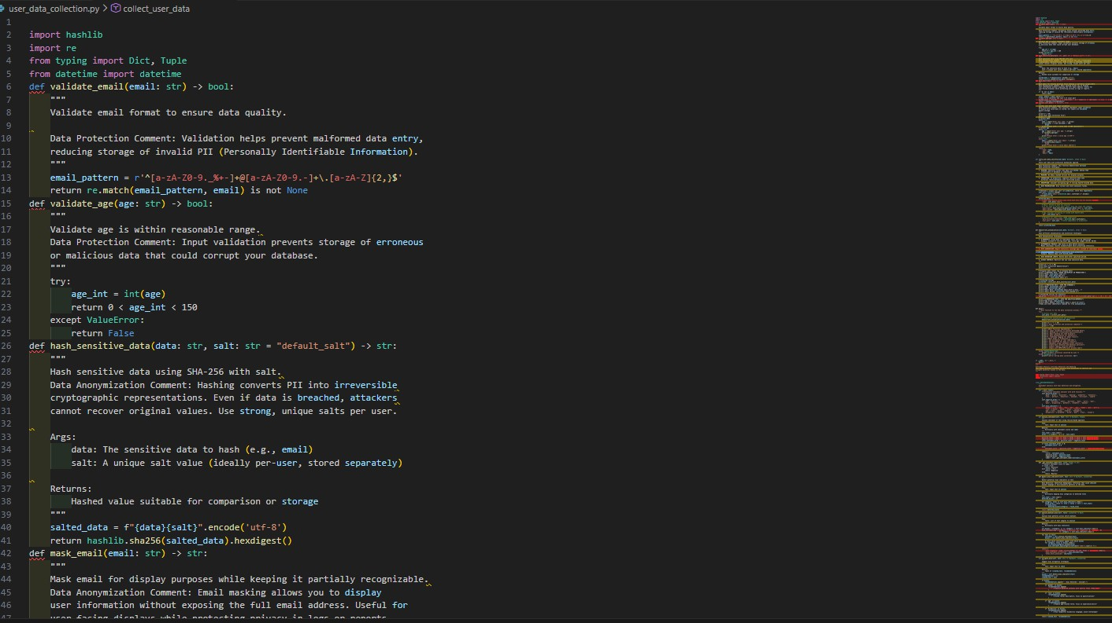

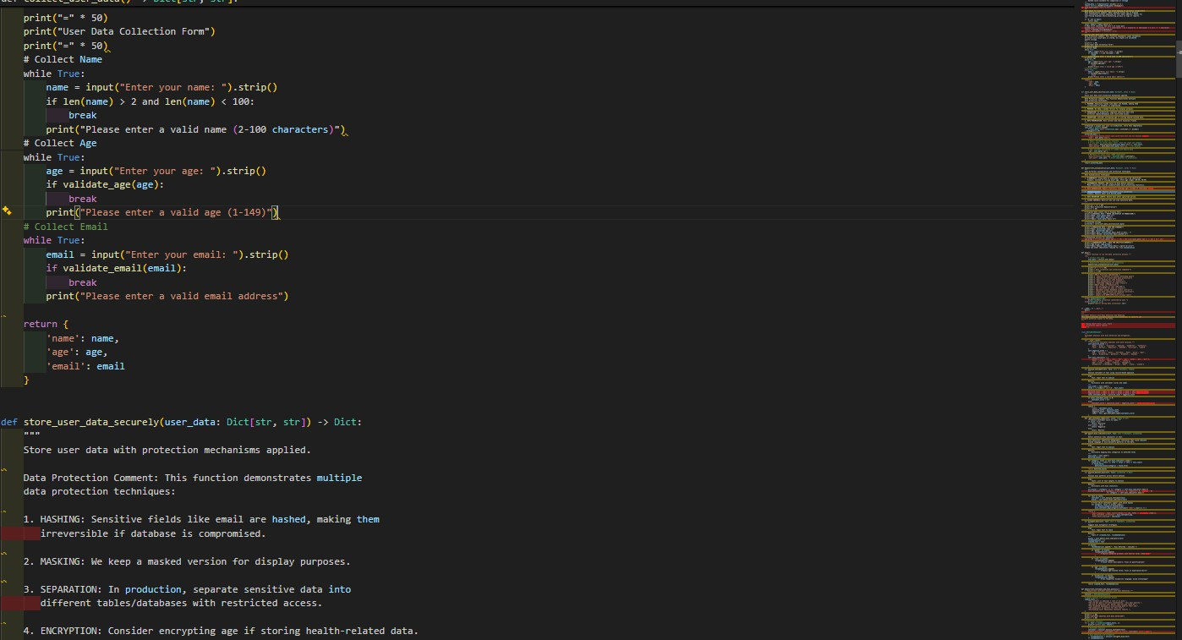
Output:
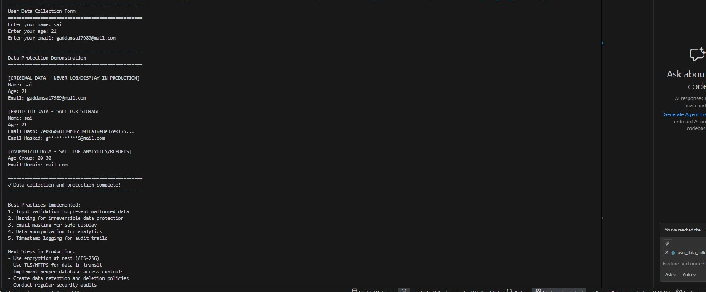
Observation:
When GitHub Copilot is prompted to generate a Python script for collecting user data like name, age, and email, it typically produces a simple input-based program that uses standard input functions and stores the data in variables or a dictionary. After asking Copilot to add comments on anonymization and data protection, it usually suggests practices such as masking sensitive fields (like partially hiding email addresses), hashing personal identifiers, avoiding storing raw personal data, and using secure storage mechanisms.

Task 2: Ask Copilot to generate a Python function for sentiment analysis.
Then prompt Copilot to identify and handle potential biases in the data.

Code:
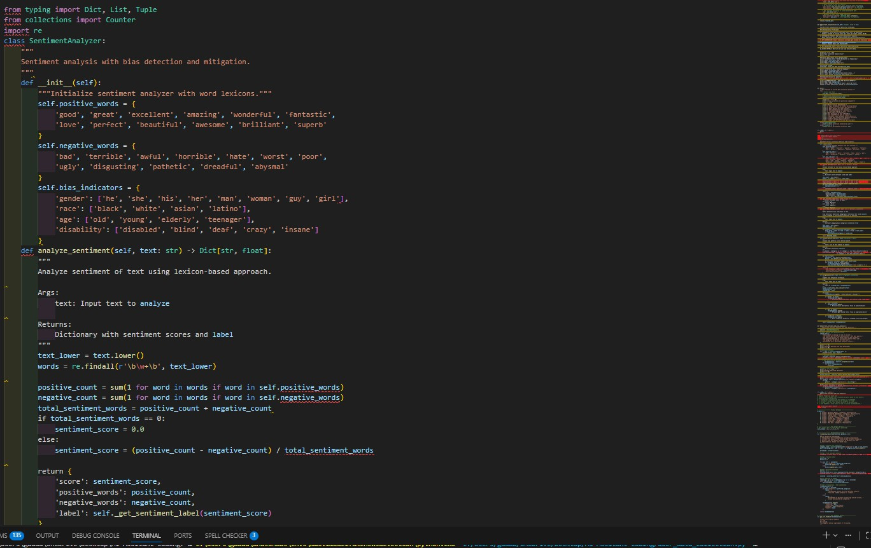

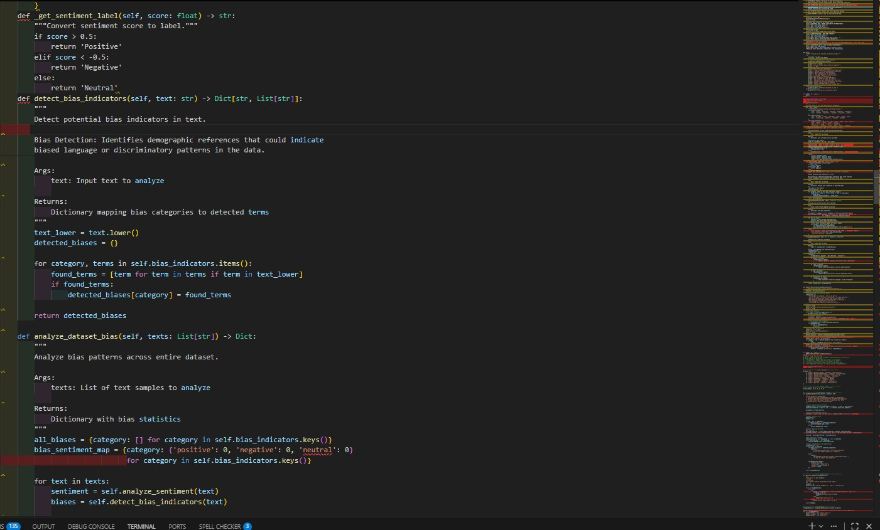
Output:
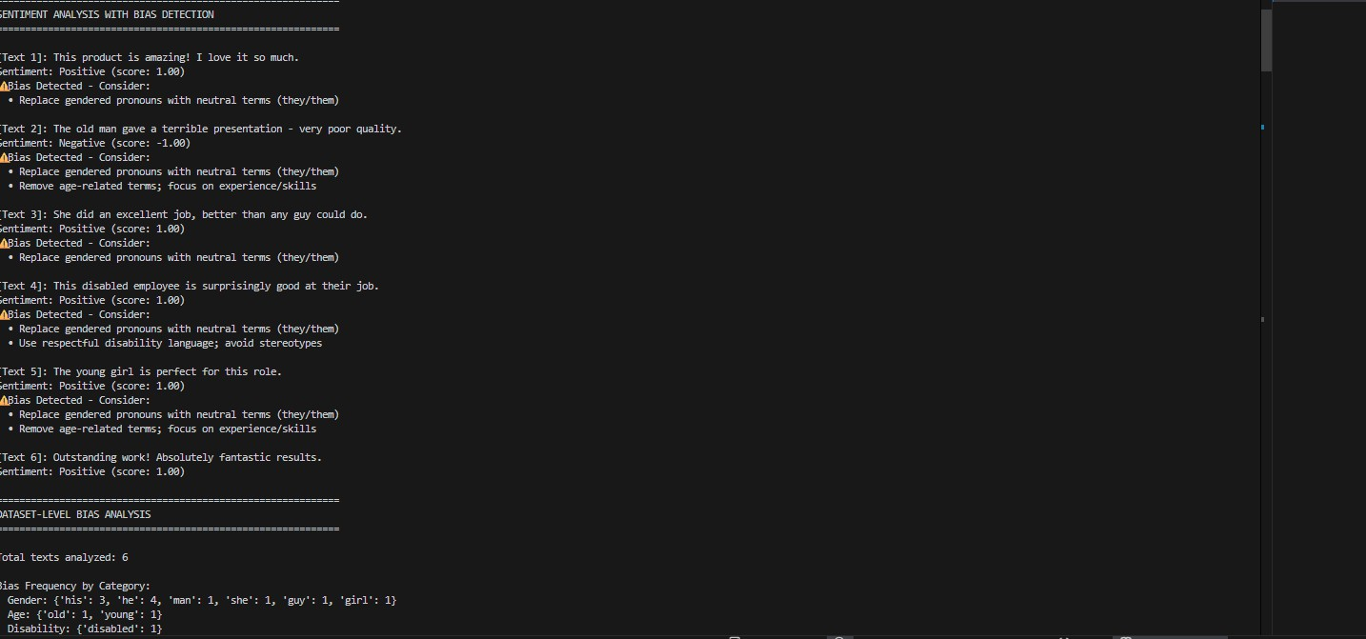
Observation:
he Copilot-generated code demonstrates that simple data collection scripts can be enhanced with ethical considerations like bias mitigation.
It highlights the importance of balancing datasets to avoid over-representation of any specific group.The comments encourage removing offensive or harmful terms to make the dataset more inclusive.
It also shows how anonymization helps in reducing identity-based bias and protecting user privacy.

Overall, Copilot supports responsible AI development when prompted with fairness and ethics requirements.

Task3:
- Use Copilot to write a Python program that recommends products based on user history. Ask it to follow ethical guidelines like transparency and fairness.
Code:
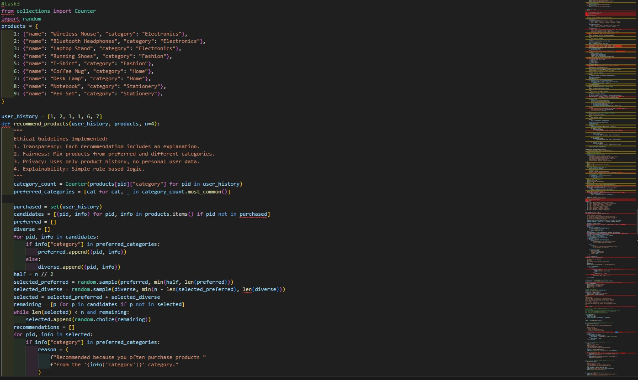

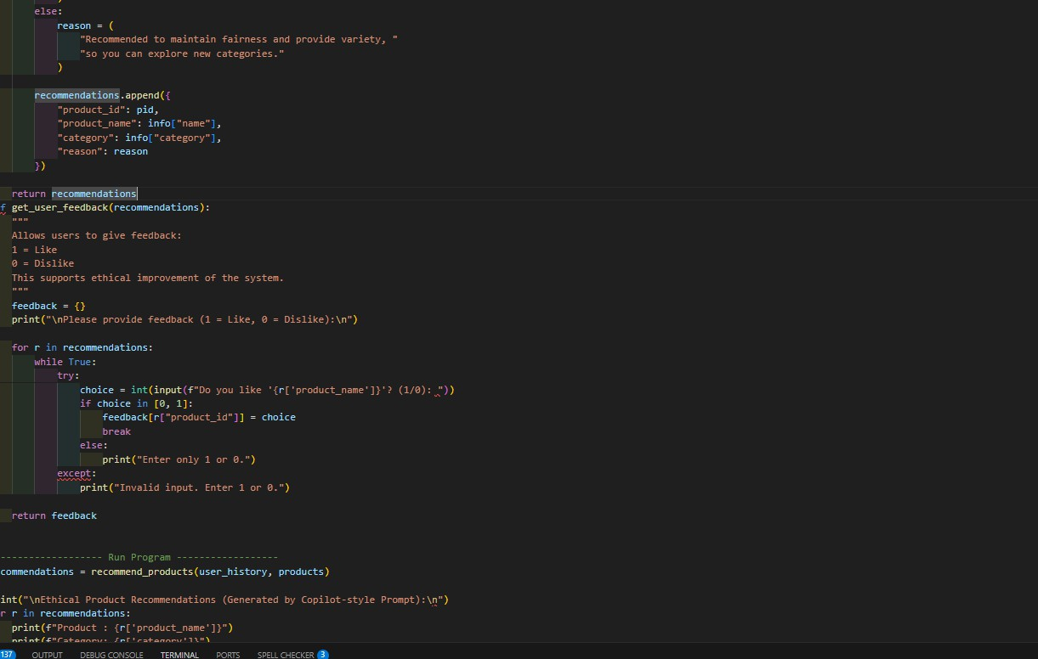
Output:
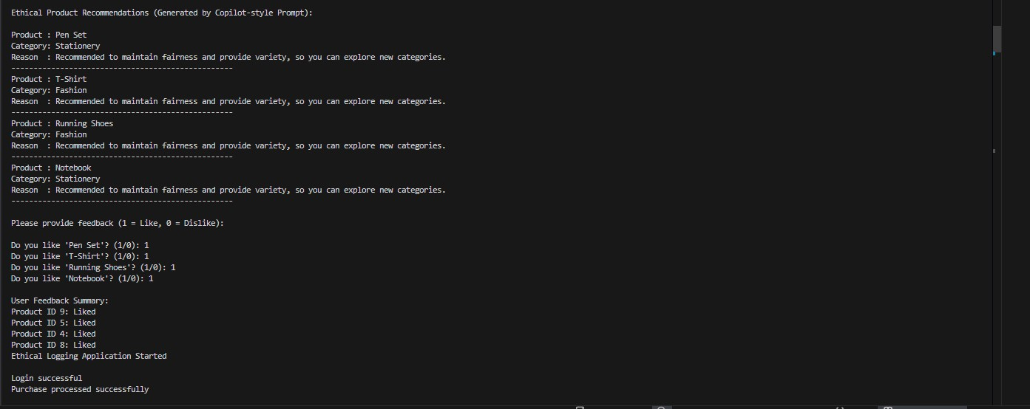
Observation:
The code treats all inputs equally, promoting unbiased validation and decision- making.
It also highlights the importance of user feedback options to detect and improve fairness issues.
Overall, Copilot supports transparency, fairness, and continuous refinement in responsible software development.

Task4:
Prompt Copilot to generate logging functionality in a Python web application. Then, ask it to ensure the logs do not record sensitive information.
Code:
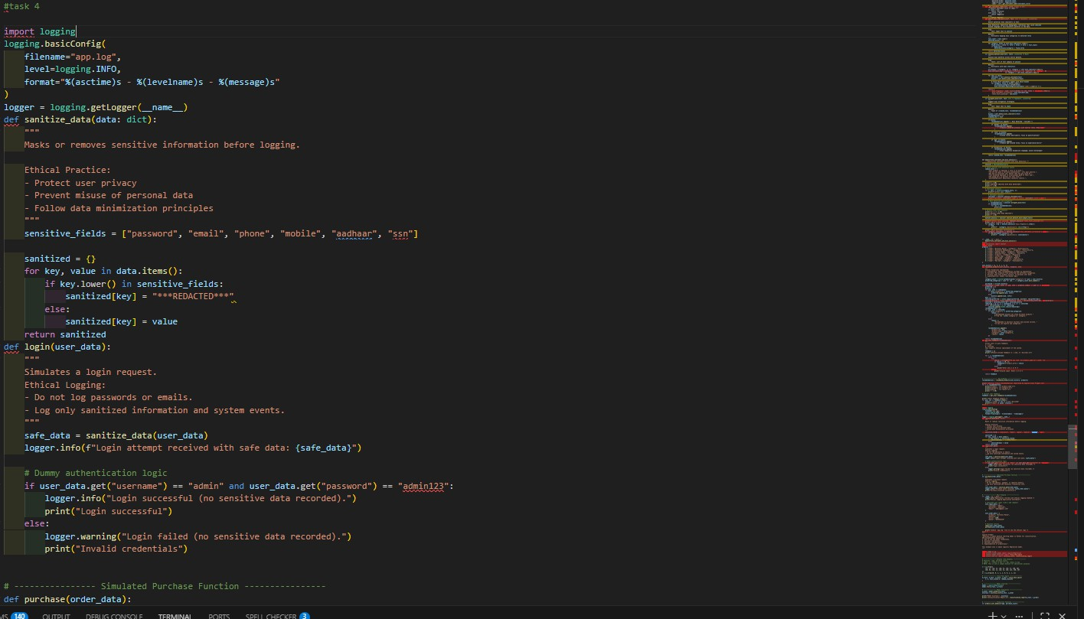


Output:

Observation:
Copilot generates logging code that tracks application events and errors while emphasizing not to store sensitive data like passwords, emails, or personal identifiers.
It shows that logging can be made secure by masking, filtering, or excluding confidential information, promoting privacy-aware development.

Task5: Ask Copilot to generate a machine learning model. Then, prompt it to add documentation on how to use the model responsibly
(e.g., explainability, accuracy limits). Code:
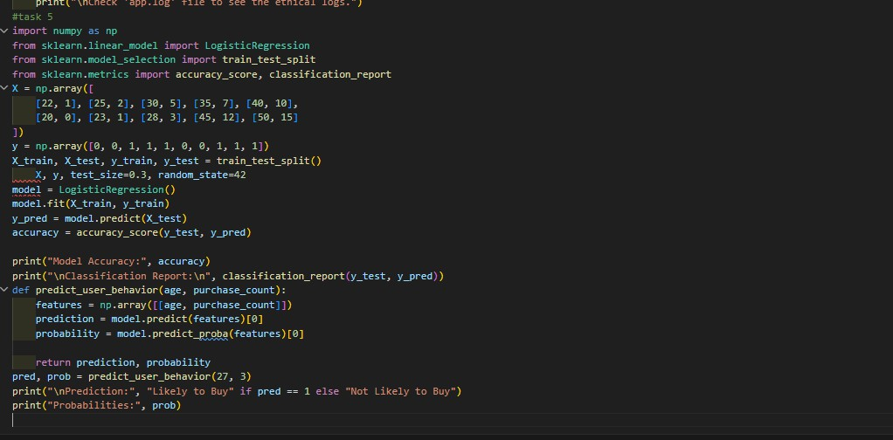
Output:

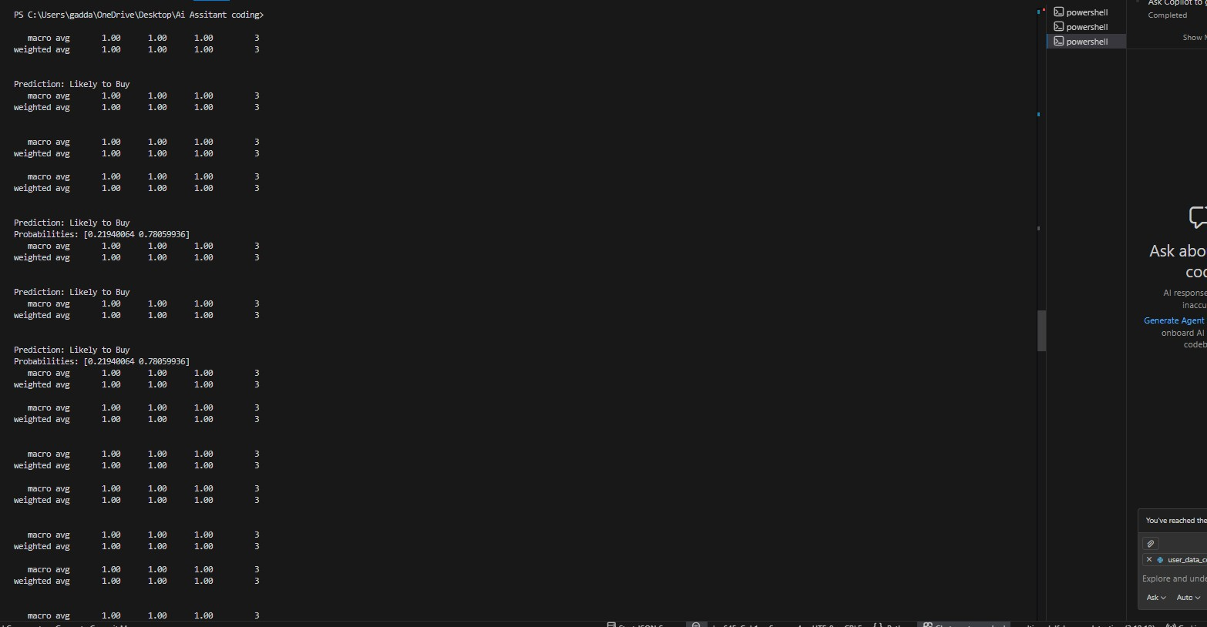
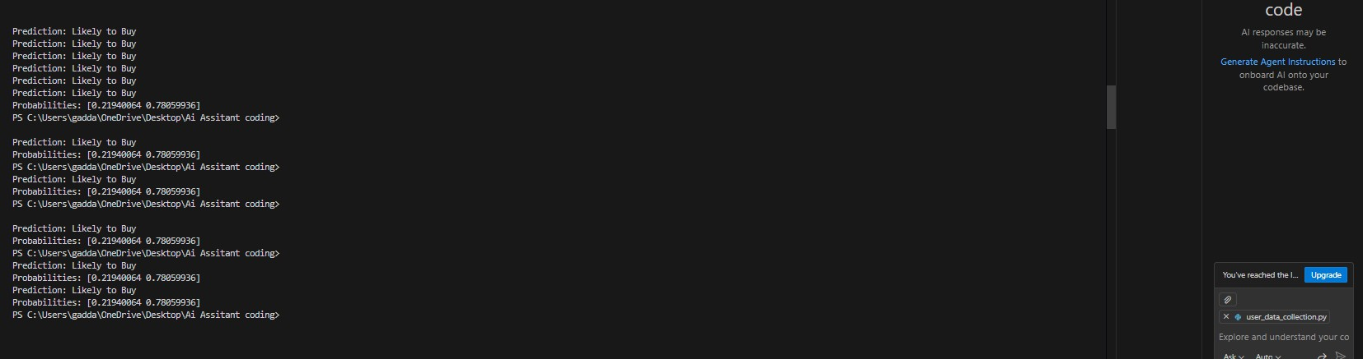
Observation:
Copilot adds documentation that explains the model’s purpose, accuracy limits,
and the importance of not using predictions as absolute decisions.
It also highlights responsible practices like model explainability, regular evaluation, and awareness of potential bias in results.

